* Family chore manager  
    
  Project description  
    
  The Family Chore Manager app is an app that helps families organize and track household chores with a built-in rewards system. Parents can assign tasks to their children, set deadlines, and assign points to each chore. Children can mark chores as completed to earn points, which can be redeemed for rewards such as more screentime, an extra snack in the evening and so on. Parents have the final say in approving or rejecting chore completion and reward claims.  
    
  User stories  
    
  **Registration**  
    
  As a new user,  
  I'm able to register for an account by providing my name, email, role and creating a password,  
  so that I can securely access the Family Chore Manager and manage tasks for my family.

Acceptance criteria:

* The user can visit the registration page and enter their name, email, role, password, and confirm password.
* A unique user ID is created for the user upon successful registration.
* The password gets hashed.

**Login**  
  
As a parent/child,  
I'm able to log in to the app using my email and password,  
so that I can access my personal dashboard and manage or complete chores.  
Acceptance criteria:

* Users are prompted to enter their email and password on the login page.
* Parents are directed to the admin (parent) dashboard upon successful login.
* Children are directed to the child dashboard upon successful login.
* An error message is displayed if incorrect credentials are provided.

**List of children**  
  
As a parent,  
I'm able to see a list of the children in my family,  
so I can see which tasks have been assigned.  
Acceptance criteria:

* When logged in, the parent can see a list of their children.
* Each child has a list of chores underneath their name.
* If no children have registered, there is a message “find people to do your chores :) “ on the screen.

**Assign task**

As a parent I can go to chores overview,  
I'm able to assign a task to one or more children,  
so that they can start their chores.

Acceptance Criteria:

* Each chore has a defined amount of points.
* A notification is sent to the child when the task is assigned.  
  **Task Status**

As a child,  
I'm able to mark a task as completed,  
so that I can notify my parent that I've finished it and earn points.

Acceptance Criteria:

* Children can mark a chore as completed with a button click.
* The task moves from the “Assigned Chores” list to the “Pending Approval” list for parents.
* A notification is sent to the parent for review.

**Chore Notification (Parent)**

As a parent,  
I'm able to receive notifications when my child marks a chore as done,  
so that I can review and approve or reject the completed task.

Acceptance Criteria:

* The parent receives a notification (push or in-app) when a child marks a task as done.
* The notification includes the task details.
* The parent can accept or reject the completion.

When accepted, points are added to the child’s “wallet”.

**Reward Notification (Parent)**

As a parent,  
I'm able to receive notifications when my child buys a reward.

Acceptance Criteria:

* The parent receives a notification (push or in-app) when a child buys a reward.

The notification includes the reward details.  
  
**Chore Notification (Parent)**

As a parent,  
I'm able to see a list of all the assignments that need my approval.  
so that I can review and approve the task.

Acceptance Criteria:

* The parent receives a notification (push or in-app) when a child marks a task as done.
* The notification includes the task details.
* The parent can go to the approval page

When accepted, points are added to the child’s “wallet”.  
  
  
**Points usage**

As a child,  
I'm able to buy benefits with my points,  
so that I am awarded for my chores.

Acceptance Criteria:

* Children can choose an item from a list of benefits.
* When bought, a popup window is shown with the message “ you have bought … show this to your parents as proof”.
* The used points will be deducted from his “wallet”.  
  Domain model  
  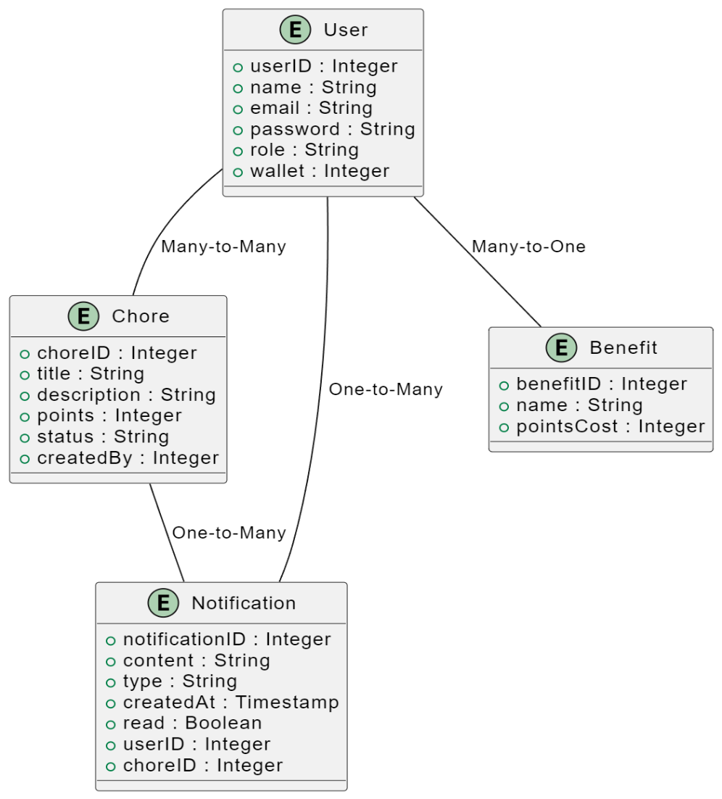

Logical database model  
  
Conceptual database model  
